Giving at St Peter’s
Prayer Themes for the Week
Pray for all Christian leaders who are in prison for their faith in Christ and their leadership of his people.

Please pray that those countries who do not allow freedom of assembly and freedom of worship will change from within, allowing people to actively live out their faith.

Please pray that in the UK those who call themselves Christians will take opportunities they have to share their faith.

Mission
Crosslinks
John and Gillian Robinson run the Place of Grace, clubs and a foodbank in five of Bangkok's needy communities in Thailand. Praise God that the recent school inspection went very well, and for the blessing of a new 21-seater school bus. Give thanks for many students getting closer to God, and for children from the five slum communities coming to the afternoon clubs where they hear about God who loves them. Pray for safety and protection for May, a young girl from the school was taken up country by her grandmother who has gambling debts. Please pray too for the vision for a safe house for boys. Two boys are in desperate need as their father is violent and drinks every day, so they are not fed or looked after.

Collect
Lord God,
your Son left the riches of heaven
and became poor for our sake:
when we prosper save us from pride,
when we are needy save us from despair,
that we may trust in you alone;
through Jesus Christ our Lord.
one God, now and for ever.

We encourage everyone who considers St Peter’s to be their Church to give regularly if they are able, to the work and ministry of the Church, not just in our community but also so that we can fulfil our commitments to our Mission partners. If you would like to set up a regular Direct payment, please contact your bank directly to arrange this and contact Carolyn in the Church Office for the Church bank details. Gift Aid forms are available in church and enable us to re-claim the tax paid on your donation.

2nd August 2026
Cleaning: Liz
Coffee: Mei & Jude
Music: Karen
9th August 2026
Cleaning: John
Coffee: Brenda & Ian
Music: Karen
16th August 2026
Cleaning: Sandie & Brenda
Coffee: Ian & Gill
Music: Justin

Church Office Administrator: Carolyn McMahon
Usually open Tuesday & Wednesday 9am – 3pm
(Closed in August)

Tel: 07927 163859
Email: dittonparish1@outlook.com
Christian Resource Library open during school term time.
*
Rector: Ross Terranova
Tel: 01732 842027
Email: ross.terranova@hotmail.co.uk
*
Safeguarding Officer: Ruth Campbell
Safeguard.stpetes@gmail.com

Website: dittonchurch.org.uk
Facebook: St Peter’s Church, Ditton

Thought for the Week
“New wine will drip from the mountains and flow from the hills”
Amos 9 v 13b
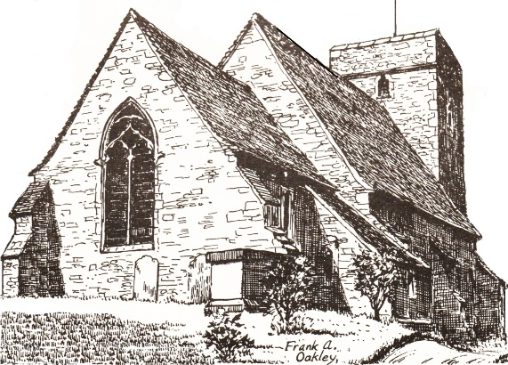
St. Peter’s Church
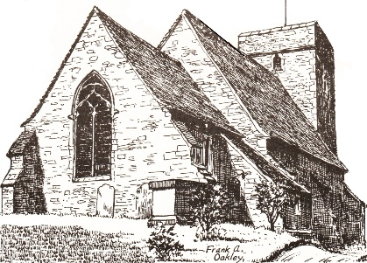

Welcome

‘We are here to demonstrate God’s love for all as shown in Jesus to people where we live and work.’

Services Today 26th July 2026
Eighth Sunday After Trinity

10.00am Morning Prayer
Leading: Ross Terranova
Reading: Judith Boarer Amos 9: 11-15, p.925
Praying: Ross Terranova
Preaching: Giles Williams

6.30pm Evening Prayer
Leading: Carol Wellbelove
Reading: Kathy Mitchell Mark 6:14-29, p.1008
Praying: Chris Williams
Preaching: Ross Terranova
_______________________________________

Sunday 2nd August 2026
Ninth Sunday After Trinity

10.00am Morning Prayer
Leading: Worship Team

6.30pm Holy Communion
Leading: Giles Williams
Reading: Ruth Campbell Luke19:1-10, p.1053
Praying: Liz Nicolaides
Preaching: DVD: Tom Parsons
Sunday 9th August 2026
Tenth Sunday After Trinity

10.00am Morning Prayer
Leading: Carol Wellbelove
Reading: Carolyn McMahon Hebrews 12:1-3
Praying: Ruth Campbell
Preaching: Rachael Knapp

6.30pm Evening Prayer
Leading: John Paul
Reading: Steve Campbell Matthew 6:1-8, p.970
Praying: Julien Myles
Preaching: DVD: A Miraculous Possibility

Welcome to Our Services Today

This morning, we conclude our short series on Amos and our theme is Ransomed, Healed, Restored, Forgiven from the closing verses. These majestic verses show a clear shift in the book from judgment to a glorious promise of restoration. God vows to rebuild King Davids fallen tent, uniting all nations in his name. He describes a future of incredible abundance, where blessings overflow, promising his people permanent security and fruitful joy.

This evening, we explore the tragic story of the death of John the Baptist. John was imprisoned for courageously condemning King Herod's unlawful marriage. It is an insight into what the cost of true conviction can sometimes lead to.

Summer Services
We are having a number of visiting speakers over August in our morning services. We are delighted to welcome back again Rev Rachael Knapp, who is Chaplain at Bennett Memorial School, and Canon John Salter. We also welcome, later in August, the Ven Nick Cornell, Archdeacon of Tonbridge who is with us on August 23rd.

Diary for w/c 26th July at St Peter’s Church
Wed
9.30am -11.00am - Crafty Coffee - Golding Room
2pm – Interment of ashes – Margaret Bye

Summer Services and Activities Morning Services
August 2nd Worship Team
August 9th Rev Rachael Knapp Chaplain at Bennett
Memorial School in Tunbridge Wells and
former Curate here.
August 16th Canon John Salter
August 23rd Archdeacon of Tonbridge
August 31st Giles Williams is Leading

Evening services
From 2nd August to 31st August, we will be enjoying a sermon via DVD from well- respected preachers from across the UK.

Prayer @ 7 will continue on Mondays in the Golding Room.

Crafty Coffee will continue on Wednesdays at 9.30am in the Golding Room.

__________________________________________

Gift Day Update
Thank you very much for your continuing response to our Gift Day. So far, the total is exceeding £6,000.00 but we anticipate and pray that there may be more donations in the next couple of weeks. A huge thank you to everyone who has given so far.
__________________________________________

Invitation To David Pearce’s Birthday Tea
David’s daughter, Alison, would like to invite everyone to David's 95th birthday tea on 15th August at 35 Priory Grove. Drop in between 2 and 4pm.
Do please let us know if you are coming by 31st July so we can arrange catering.
RSVP Alison 07507 094 606

Food Bank
St Peter’s Church now supports the foodbank run by Larkfield Community Church.
Thank you so much for your generous donations to the Larkfield Foodbank.
The next collection date will be Sunday 30th Aug. Please bring your donations to church on or before that date. Many thanks.
To access the food bank, please email: foodbank@larkfieldcommunitychurch.co.uk
______________________________________

Reading/ Praying/ Coffee Rotas
Carolyn will soon be drawing up new rotas for September to December. If you have not yet her know any particular requests and know of holidays/time away you have planned, please email the church office by the end of July. Thank you.
______________________________________

Church Office Hours This Week
The office will be open on Friday31st July ONLY.
______________________________________

Church Office Hours Over Summer
Although the Church Office will be closed during August, Carolyn will be working from home several days of August and will keeping an eye on Church emails.
The Church Office will resume normal hours on Tuesday 1st September

